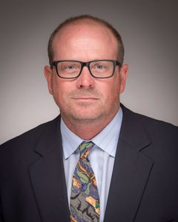Brian S. J. Blagg, Ph.D.

Director, Warren Center for Drug Discovery

Charles Huisking Professor of Chemistry and Biochemistry

Associate Editor, the Journal of Medicinal Chemistry

Before joining the University of Notre Dame in 2017 as the director of Warren Center for Drug Discovery, Professor Blagg was Lester and Betty Mitscher Professor at the University of Kansas. Since 2018, he has been a member of the editorial board for the International Journal of Molecular Sciences. He also served as an ad hoc member with NIH as well being on the editorial board for numerous scientific journals. His interests pertain to the development of isoform-selective inhibitors for the treatment of various diseases. His talk will be on Hsp90 is a molecular chaperone that is responsible for the conformational maturation of ~300 peptide substrates, most of which are involved in signaling cascades that are hijacked during malignant transformation. Consequently, Hsp90 represents a promising therapeutic target for the development of anti-cancer agents. Hsp90 is also the master regulator of the pro-survival heat shock response that provides cyto protection for cells exposed to cellular stress. Therefore, Hsp90 can be a therapeutic target for the treatment of cancer as well as neurodegenerative diseases. Based on the natural products geldanamycin,radicicol, novobiocin and cruentaren A, small molecules have been discovered that can segregate these opposing properties and provide a platform for modern drug discovery efforts aimed at treating these diseases. The development of anti-cancer agents, neuroprotective agents, and anti-glaucoma treatments will be discussed and will highlight the polarizing role played by Hsp90 in various disease states.

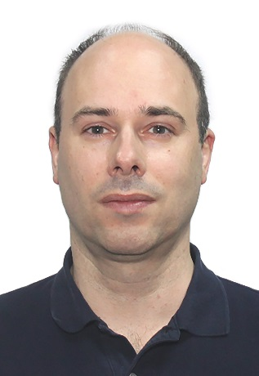**Courtney C. Aldrich, Ph.D.**

Professor of Medicinal Chemistry

College of Pharmacy

University of Minnesota

Editor-in-chief of *ACS Infectious Diseases*

Dr. Courtney Aldrich is a Professor in the Department of Medicinal Chemistry in the College of Pharmacy at the University of Minnesota and was a Visiting Professor at the Institute of Materia Medica, Peking Union Medical College & Chinese Academy of Medical Sciences from 10.2015 to 10.2018. He is the editor-in-chief of *ACS Infectious Diseases* (IF = 4.911), the first journal to highlight chemistry and its role in the multidisciplinary and collaborative field of infectious disease research. His research focuses on the design of new antibiotics for multidrug-resistant bacteria and natural product biosynthesis. Dr. Aldrich’s research has been supported by the National Institutes of Health, the Bill & Melinda Gates Foundation, and the Tres Cantos Open Lab Foundation. As an educator, Dr. Aldrich teaches courses in both the graduate and professional programs on antimicrobial agents and has mentored more than 35 PhD students and postdoctoral fellows.